**Express JS Home**

Express is a minimal and flexible Node.js web application framework that provides a robust set of features for web and mobile applications. It is an open source framework developed and maintained by the Node.js foundation.

**Audience**

This tutorial has been created for anyone who has a basic knowledge of HTML, Javascript and how client-servers work. After completing this tutorial, you will be able to build moderately complex websites and back-ends for you mobile applications.

**Prerequisites**

You should have basic knowledge of Javascript and HTML. If you are not acquainted with these, we suggest you to go through tutorials on those areas first. It will definitely help, if you have some exposure to HTTP, although it is not mandatory. Having a basic knowledge of MongoDB will help you with the Database chapter.

**Express JS Overview**

ExpressJS is a web application framework that provides you with a simple API to build websites, web apps and back ends. With ExpressJS, you need not worry about low level protocols, processes, etc.

## What is Express?

Express provides a minimal interface to build our applications. It provides us the tools that are required to build our app. It is flexible as there are numerous modules available on **npm**, which can be directly plugged into Express.

Express was developed by **TJ Holowaychuk** and is maintained by the [Node.js](https://nodejs.org/en/) foundation and numerous open source contributors.

## Why Express?

Unlike its competitors like Rails and Django, which have an opinionated way of building applications, Express has no "best way" to do something. It is very flexible and pluggable.

### Pug

Pug (earlier known as Jade) is a terse language for writing HTML templates. It −

* Produces HTML
* Supports dynamic code
* Supports reusability (DRY)

It is one of the most popular template language used with Express.

## MongoDB and Mongoose

MongoDB is an open-source, document database designed for ease of development and scaling. This database is also used to store data.

Mongoose is a client API for **node.js** which makes it easy to access our database from our Express application.

**Express JS Environment**

In this chapter, we will learn how to start developing and using the Express Framework. To start with, you should have the Node and the npm (node package manager) installed. If you don’t already have these, go to the [Node setup](https://www.tutorialspoint.com/nodejs/nodejs_environment_setup.htm) to install node on your local system. Confirm that node and npm are installed by running the following commands in your terminal.

node --version

npm --version

You should get an output similar to the following.

v5.0.0

3.5.2

Now that we have Node and **npm** set up, let us understand what **npm** is and how to use it.

## Node Package Manager(npm)

npm is the package manager for node. The npm Registry is a public collection of packages of open-source code for Node.js, front-end web apps, mobile apps, robots, routers, and countless other needs of the JavaScript community. npm allows us to access all these packages and install them locally. You can browse through the list of packages available on npm at [npmJS](https://www.npmjs.com/" \t "_blank).

### How to use npm?

There are two ways to install a package using npm: globally and locally.

* **Globally** − This method is generally used to install development tools and CLI based packages. To install a package globally, use the following code.

npm install -g <package-name>

* **Locally** − This method is generally used to install frameworks and libraries. A locally installed package can be used only within the directory it is installed. To install a package locally, use the same command as above without the **-g** flag.

npm install <package-name>

Whenever we create a project using npm, we need to provide a **package.json**file, which has all the details about our project. npm makes it easy for us to set up this file. Let us set up our development project.

**Step 1** − Start your terminal/cmd, create a new folder named hello-world and cd (create directory) into it −

npm init info

**Step 2** − Now to create the package.json file using npm, use the following code.

npm init

It will ask you for the following information.

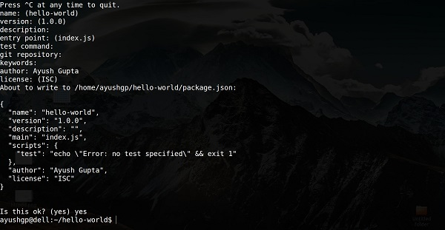

Just keep pressing enter, and enter your name at the “author name” field.

**Step 3** − Now we have our package.json file set up, we will further install Express. To install Express and add it to our package.json file, use the following command −

npm install --save express

To confirm that Express has installed correctly, run the following code.

ls node\_modules #(dir node\_modules for windows)

**Tip** − The --**save** flag can be replaced by the **-S** flag. This flag ensures that Express is added as a dependency to our **package.json** file. This has an advantage, the next time we need to install all the dependencies of our project we can just run the command *npm install* and it will find the dependencies in this file and install them for us.

This is all we need to start development using the Express framework. To make our development process a lot easier, we will install a tool from npm, nodemon. This tool restarts our server as soon as we make a change in any of our files, otherwise we need to restart the server manually after each file modification. To install nodemon, use the following command −

npm install -g nodemon

You can now start working on Express.

**Express JS Hello World Application**

We have set up the development, now it is time to start developing our first app using Express. Create a new file called **index.js** and type the following in it.

var express = require('express');

var app = express();

app.get('/', function(req, res){

res.send("Hello world!");

});

app.listen(3000);

Save the file, go to your terminal and type the following.

nodemon index.js

This will start the server. To test this app, open your browser and go to **http://localhost:3000** and a message will be displayed as in the following screenshot.

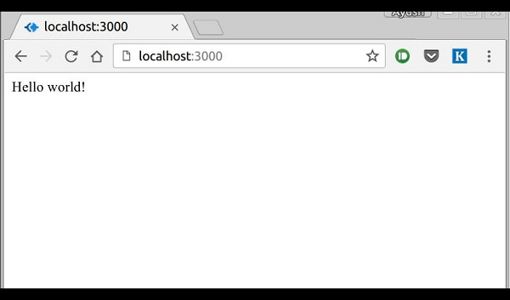

## How the App Works?

The first line imports Express in our file, we have access to it through the variable Express. We use it to create an application and assign it to var app.

### app.get(route, callback)

This function tells what to do when a **get** request at the given route is called. The callback function has 2 parameters, ***request(req)*** and ***response(res)***. The request **object(req)** represents the HTTP request and has properties for the request query string, parameters, body, HTTP headers, etc. Similarly, the response object represents the HTTP response that the Express app sends when it receives an HTTP request.

### res.send()

This function takes an object as input and it sends this to the requesting client. Here we are sending the string *"Hello World!"*.

### app.listen(port, [host], [backlog], [callback]])

This function binds and listens for connections on the specified host and port. Port is the only required parameter here.

|  |  |
| --- | --- |
| **S.No.** | **Argument & Description** |
| 1 | **Port**  A port number on which the server should accept incoming requests. |
| 2 | **Host**  Name of the domain. You need to set it when you deploy your apps to the cloud. |
| 3 | **Backlog**  The maximum number of queued pending connections. The default is 511. |
| 4 | **Callback**  An asynchronous function that is called when the server starts listening for requests. |

**Express JS Routing**

Web frameworks provide resources such as HTML pages, scripts, images, etc. at different routes.

The following function is used to define routes in an Express application −

## app.method(path, handler)

This METHOD can be applied to any one of the HTTP verbs – get, set, put, delete. An alternate method also exists, which executes independent of the request type.

Path is the route at which the request will run.

Handler is a callback function that executes when a matching request type is found on the relevant route. For example,

var express = require('express');

var app = express();

app.get('/hello', function(req, res){

res.send("Hello World!");

});

app.listen(3000);

If we run our application and go to **localhost:3000/hello**, the server receives a get request at route **"/hello"**, our Express app executes the **callback** function attached to this route and sends **"Hello World!"** as the response.

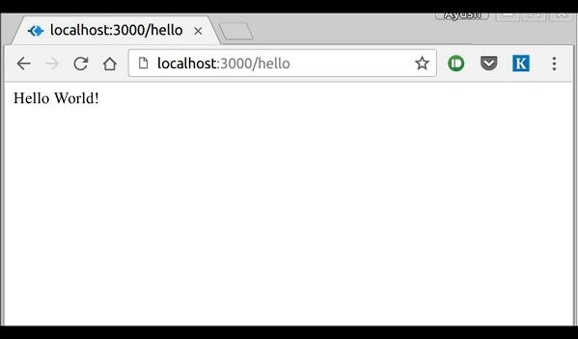

We can also have multiple different methods at the same route. For example,

var express = require('express');

var app = express();

app.get('/hello', function(req, res){

res.send("Hello World!");

});

app.post('/hello', function(req, res){

res.send("You just called the post method at '/hello'!\n");

});

app.listen(3000);

To test this request, open up your terminal and use cURL to execute the following request −

curl -X POST "http://localhost:3000/hello"

Curl request

A special method, ***all***, is provided by Express to handle all types of http methods at a particular route using the same function. To use this method, try the following.

app.all('/test', function(req, res){

res.send("HTTP method doesn't have any effect on this route!");

});

This method is generally used for defining middleware, which we'll discuss in the middleware chapter.

## Routers

Defining routes like above is very tedious to maintain. To separate the routes from our main **index.js** file, we will use **Express.Router**. Create a new file called **things.js** and type the following in it.

var express = require('express');

var router = express.Router();

router.get('/', function(req, res){

res.send('GET route on things.');

});

router.post('/', function(req, res){

res.send('POST route on things.');

});

//export this router to use in our index.js

module.exports = router;

Now to use this router in our **index.js**, type in the following before the **app.listen** function call.

var express = require('Express');

var app = express();

var things = require('./things.js');

//both index.js and things.js should be in same directory

app.use('/things', things);

app.listen(3000);

The ***app.use*** function call on route **'/things'** attaches the **things** router with this route. Now whatever requests our app gets at the '/things', will be handled by our things.js router. The **'/'** route in things.js is actually a subroute of '/things'. Visit localhost:3000/things/ and you will see the following output.

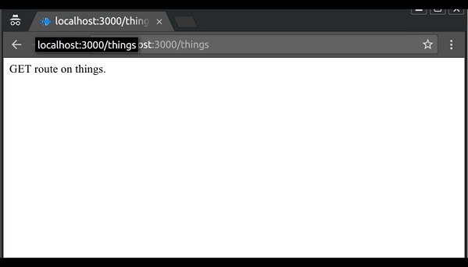

Routers are very helpful in separating concerns and keep relevant portions of our code together. They help in building maintainable code. You should define your routes relating to an entity in a single file and include it using the above method in your **index.js** file.

**Express JS – HTTP method**

The HTTP method is supplied in the request and specifies the operation that the client has requested. The following table lists the most used HTTP methods −

|  |  |
| --- | --- |
| **S.No.** | **Method & Description** |
| 1 | **GET**  The GET method requests a representation of the specified resource. Requests using GET should only retrieve data and should have no other effect. |
| 2 | **POST**  The POST method requests that the server accept the data enclosed in the request as a new object/entity of the resource identified by the URI. |
| 3 | **PUT**  The PUT method requests that the server accept the data enclosed in the request as a modification to existing object identified by the URI. If it does not exist then the PUT method should create one. |
| 4 | **DELETE**  The DELETE method requests that the server delete the specified resource. |

These are the most common HTTP methods. To learn more about the methods, visit [http://www.tutorialspoint.com/http/http\_methods.htm](https://www.tutorialspoint.com/http/http_methods.htm).

Express JS URL Binding

We can now define routes, but those are static or fixed. To use the dynamic routes, we SHOULD provide different types of routes. Using dynamic routes allows us to pass parameters and process based on them.

Here is an example of a dynamic route −

var express = require('express');

var app = express();

app.get('/:id', function(req, res){

res.send('The id you specified is ' + req.params.id);

});

app.listen(3000);

To test this go to **http://localhost:3000/123**. The following response will be displayed.

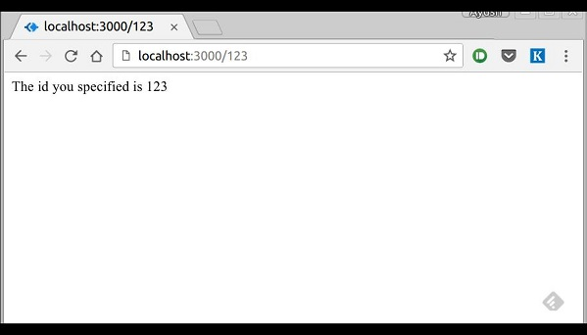

You can replace '123' in the URL with anything else and the change will reflect in the response. A more complex example of the above is −

var express = require('express');

var app = express();

app.get('/things/:name/:id', function(req, res) {

res.send('id: ' + req.params.id + ' and name: ' + req.params.name);

});

app.listen(3000);

To test the above code, go to **http://localhost:3000/things/tutorialspoint/12345**.

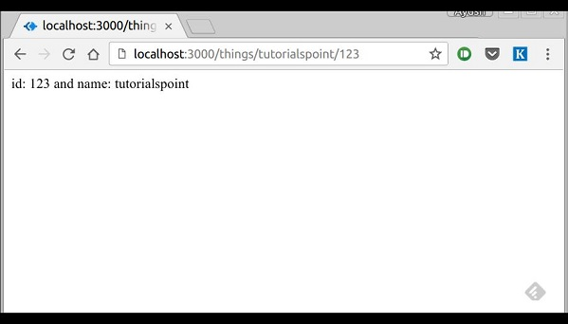

You can use the ***req.params*** object to access all the parameters you pass in the url. Note that the above 2 are different paths. They will never overlap. Also if you want to execute code when you get **'/things'** then you need to define it separately.

## Pattern Matched Routes

You can also use **regex** to restrict URL parameter matching. Let us assume you need the **id** to be a 5-digit long number. You can use the following route definition −

var express = require('express');

var app = express();

app.get('/things/:id([0-9]{5})', function(req, res){

res.send('id: ' + req.params.id);

});

app.listen(3000);

Note that this will **only** match the requests that have a 5-digit long **id**. You can use more complex regexes to match/validate your routes. If none of your routes match the request, you'll get a ***"Cannot GET <your-request-route>"*** message as response. This message be replaced by a 404 not found page using this simple route −

var express = require('express');

var app = express();

//Other routes here

app.get('\*', function(req, res){

res.send('Sorry, this is an invalid URL.');

});

app.listen(3000);

**Important** − This should be placed after all your routes, as Express matches routes from start to end of the **index.js** file, including the external routers you required.

For example, if we define the same routes as above, on requesting with a valid URL, the following output is displayed. −

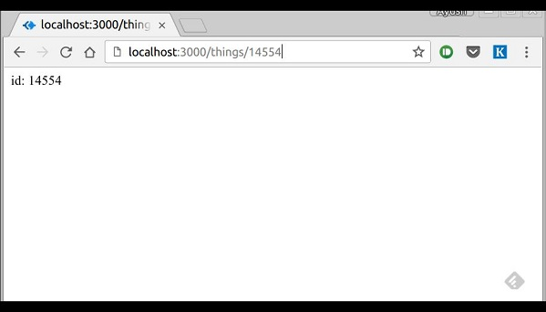

While for an incorrect URL request, the following output is displayed.

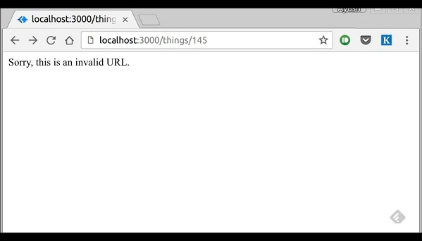

**Express JS Middle ware**

Middleware functions are functions that have access to the **request object (req)**, the **response object (res)**, and the next middleware function in the application’s request-response cycle. These functions are used to modify **req**and **res** objects for tasks like parsing request bodies, adding response headers, etc.

Here is a simple example of a middleware function in action −

var express = require('express');

var app = express();

//Simple request time logger

app.use(function(req, res, next){

console.log("A new request received at " + Date.now());

//This function call is very important. It tells that more processing is

//required for the current request and is in the next middleware

function/route handler.

next();

});

app.listen(3000);

The above middleware is called for every request on the server. So after every request, we will get the following message in the console −

A new request received at 1467267512545

To restrict it to a specific route (and all its subroutes), provide that route as the first argument of ***app.use()***. For Example,

var express = require('express');

var app = express();

//Middleware function to log request protocol

app.use('/things', function(req, res, next){

console.log("A request for things received at " + Date.now());

next();

});

// Route handler that sends the response

app.get('/things', function(req, res){

res.send('Things');

});

app.listen(3000);

Now whenever you request any subroute of '/things', only then it will log the time.

### Order of Middleware Calls

One of the most important things about middleware in Express is the order in which they are written/included in your file; the order in which they are executed, given that the route matches also needs to be considered.

For example, in the following code snippet, the first function executes first, then the route handler and then the end function. This example summarizes how to use middleware before and after route handler; also how a route handler can be used as a middleware itself.

var express = require('express');

var app = express();

//First middleware before response is sent

app.use(function(req, res, next){

console.log("Start");

next();

});

//Route handler

app.get('/', function(req, res, next){

res.send("Middle");

next();

});

app.use('/', function(req, res){

console.log('End');

});

app.listen(3000);

When we visit '/' after running this code, we receive the response as **Middle**and on our console −

Start

End

The following diagram summarizes what we have learnt about middleware −

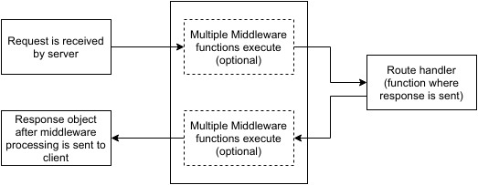

Now that we have covered how to create our own middleware, let us discuss some of the most commonly used community created middleware.

## Third Party Middleware

A list of Third party middleware for Express is available [here](http://expressjs.com/en/resources/middleware.html). Following are some of the most commonly used middleware; we will also learn how to use/mount these −

### body-parser

This is used to parse the body of requests which have payloads attached to them. To mount body parser, we need to install it using **npm install** --save body-parser and to mount it, include the following lines in your index.js −

var bodyParser = require('body-parser');

//To parse URL encoded data

app.use(bodyParser.urlencoded({ extended: false }))

//To parse json data

app.use(bodyParser.json())

To view all available options for body-parser, visit its github page.

### cookie-parser

It parses *Cookie* header and populate req.cookies with an object keyed by cookie names. To mount cookie parser, we need to install it using npm install --save cookie-parser and to mount it, include the following lines in your index.js −

var cookieParser = require('cookie-parser');

app.use(cookieParser())

### express-session

It creates a session middleware with the given options. We will discuss its usage in the Sessions section.

We have many other third party middleware in ExpressJS. However, we have discussed only a few important ones here.

**Express JS Templating**

Pug is a templating engine for Express. Templating engines are used to remove the cluttering of our server code with HTML, concatenating strings wildly to existing HTML templates. Pug is a very powerful templating engine which has a variety of features including **filters, includes, inheritance, interpolation**, etc. There is a lot of ground to cover on this.

To use Pug with Express, we need to install it,

npm install --save pug

Now that Pug is installed, set it as the templating engine for your app. You **don't** need to 'require' it. Add the following code to your **index.js** file.

app.set('view engine', 'pug');

app.set('views','./views');

Now create a new directory called views. Inside that create a file called **first\_view.pug**, and enter the following data in it.

doctype html

html

head

title = "Hello Pug"

body

p.greetings#people Hello World!

To run this page, add the following route to your app −

app.get('/first\_template', function(req, res){

res.render('first\_view');

});

You will get the output as − **Hello World!** Pug converts this very simple looking markup to html. We don’t need to keep track of closing our tags, no need to use class and id keywords, rather use '.' and **'#'** to define them. The above code first gets converted to −

<!DOCTYPE html>

<html>

<head>

<title>Hello Pug</title>

</head>

<body>

<p class = "greetings" id = "people">Hello World!</p>

</body>

</html>

Pug is capable of doing much more than simplifying HTML markup.

## Important Features of Pug

Let us now explore a few important features of Pug.

### Simple Tags

Tags are nested according to their indentation. Like in the above example, **<title>** was indented within the **<head>** tag, so it was inside it. But the **<body>** tag was on the same indentation, so it was a sibling of the **<head>**tag.

We don’t need to close tags, as soon as Pug encounters the next tag on same or outer indentation level, it closes the tag for us.

To put text inside of a tag, we have 3 methods −

* **Space seperated**

h1 Welcome to Pug

* **Piped text**

div

| To insert multiline text,

| You can use the pipe operator.

* **Block of text**

div.

But that gets tedious if you have a lot of text.

You can use "." at the end of tag to denote block of text.

To put tags inside this block, simply enter tag in a new line and

indent it accordingly.

### Comments

Pug uses the same syntax as **JavaScript(//)** for creating comments. These comments are converted to the html comments(<!--comment-->). For example,

//This is a Pug comment

This comment gets converted to the following.

<!--This is a Pug comment-->

### Attributes

To define attributes, we use a comma separated list of attributes, in parenthesis. Class and ID attributes have special representations. The following line of code covers defining attributes, classes and id for a given html tag.

div.container.column.main#division(width = "100", height = "100")

This line of code, gets converted to the following. −

<div class = "container column main" id = "division" width = "100" height = "100"></div>

### Passing Values to Templates

When we render a Pug template, we can actually pass it a value from our route handler, which we can then use in our template. Create a new route handler with the following.

var express = require('express');

var app = express();

app.get('/dynamic\_view', function(req, res){

res.render('dynamic', {

name: "TutorialsPoint",

url:"http://www.tutorialspoint.com"

});

});

app.listen(3000);

And create a new view file in views directory, called **dynamic.pug**, with the following code −

html

head

title=name

body

h1=name

a(href = url) URL

Open localhost:3000/dynamic\_view in your browser; You should get the following output −

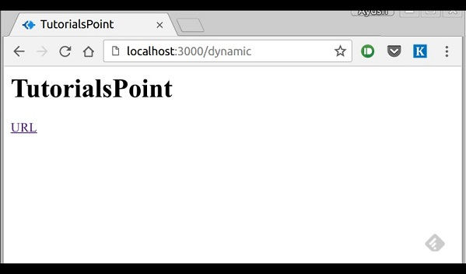

We can also use these passed variables within text. To insert passed variables in between text of a tag, we use **#{variableName}** syntax. For example, in the above example, if we wanted to put Greetings from TutorialsPoint, then we could have done the following.

html

head

title = name

body

h1 Greetings from #{name}

a(href = url) URL

This method of using values is called **interpolation**. The above code will display the following output. −

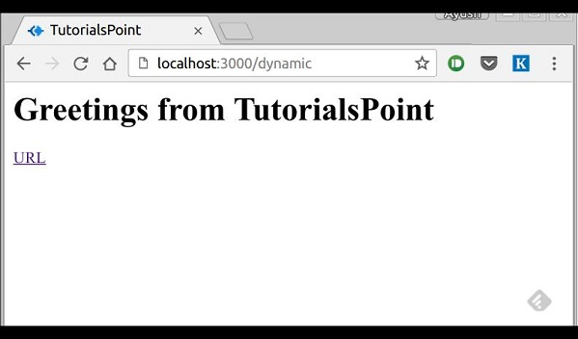

### Conditionals

We can use conditional statements and looping constructs as well.

Consider the following −

If a User is logged in, the page should display **"Hi, User"** and if not, then the **"Login/Sign Up"** link. To achieve this, we can define a simple template like −

html

head

title Simple template

body

if(user)

h1 Hi, #{user.name}

else

a(href = "/sign\_up") Sign Up

When we render this using our routes, we can pass an object as in the following program −

res.render('/dynamic',{

user: {name: "Ayush", age: "20"}

});

You will receive a message − **Hi, Ayush**. But if we don’t pass any object or pass one with no user key, then we will get a signup link.

### Include and Components

Pug provides a very intuitive way to create components for a web page. For example, if you see a news website, the header with logo and categories is always fixed. Instead of copying that to every view we create, we can use the **include** feature. Following example shows how we can use this feature −

Create 3 views with the following code −

**HEADER.PUG**

div.header.

I'm the header for this website.

**CONTENT.PUG**

html

head

title Simple template

body

include ./header.pug

h3 I'm the main content

include ./footer.pug

**FOOTER.PUG**

div.footer.

I'm the footer for this website.

Create a route for this as follows −

var express = require('express');

var app = express();

app.get('/components', function(req, res){

res.render('content');

});

app.listen(3000);

Go to localhost:3000/components, you will receive the following output −

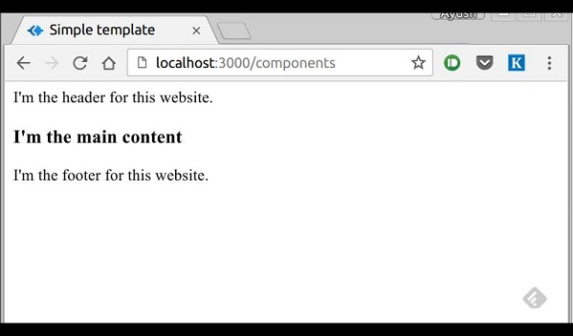

***include*** can also be used to include plaintext, css and JavaScript.

There are many more features of Pug. But those are out of the scope for this tutorial. You can further explore Pug at [Pug](http://jade-lang.com/)

**Express JS Serving Static File-**

Static files are files that clients download as they are from the server. Create a new directory, **public**. Express, by default does not allow you to serve static files. You need to enable it using the following built-in middleware.

app.use(express.static('public'));

**Note** − Express looks up the files relative to the static directory, so the name of the static directory is not part of the URL.

Note that the root route is now set to your public dir, so all static files you load will be considering public as root. To test that this is working fine, add any image file in your new **public** dir and change its name to "**testimage.jpg**". In your views, create a new view and include this file like −

html

head

body

h3 Testing static file serving:

img(src = "/testimage.jpg", alt = "Testing Image

You should get the following output −

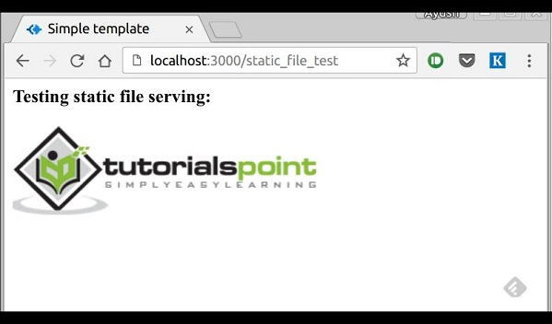

## Multiple Static Directories

We can also set multiple static assets directories using the following program −

var express = require('express');

var app = express();

app.use(express.static('public'));

app.use(express.static('images'));

app.listen(3000);

## Virtual Path Prefix

We can also provide a path prefix for serving static files. For example, if you want to provide a path prefix like **'/static'**, you need to include the following code in your **index.js** file −

var express = require('express');

var app = express();

app.use('/static', express.static('public'));

app.listen(3000);

Now whenever you need to include a file, for example, a script file called main.js residing in your public directory, use the following script tag −

<script src = "/static/main.js" />

This technique can come in handy when providing multiple directories as static files. These prefixes can help distinguish between multiple directories.

**Express JS form data**

Forms are an integral part of the web. Almost every website we visit offers us forms that submit or fetch some information for us. To get started with forms, we will first install the *body-parser*(for parsing JSON and url-encoded data) and multer(for parsing multipart/form data) middleware.

To install the *body-parser* and *multer*, go to your terminal and use −

npm install --save body-parser multer

Replace your **index.js** file contents with the following code −

var express = require('express');

var bodyParser = require('body-parser');

var multer = require('multer');

var upload = multer();

var app = express();

app.get('/', function(req, res){

res.render('form');

});

app.set('view engine', 'pug');

app.set('views', './views');

// for parsing application/json

app.use(bodyParser.json());

// for parsing application/xwww-

app.use(bodyParser.urlencoded({ extended: true }));

//form-urlencoded

// for parsing multipart/form-data

app.use(upload.array());

app.use(express.static('public'));

app.post('/', function(req, res){

console.log(req.body);

res.send("recieved your request!");

});

app.listen(3000);

After importing the body parser and multer, we will use the **body-parser** for parsing json and x-www-form-urlencoded header requests, while we will use **multer** for parsing multipart/form-data.

Let us create an html form to test this out. Create a new view called **form.pug** with the following code −

html

html

head

title Form Tester

body

form(action = "/", method = "POST")

div

label(for = "say") Say:

input(name = "say" value = "Hi")

br

div

label(for = "to") To:

input(name = "to" value = "Express forms")

br

button(type = "submit") Send my greetings

Run your server using the following.

nodemon index.js

Now go to localhost:3000/ and fill the form as you like, and submit it. The following response will be displayed −

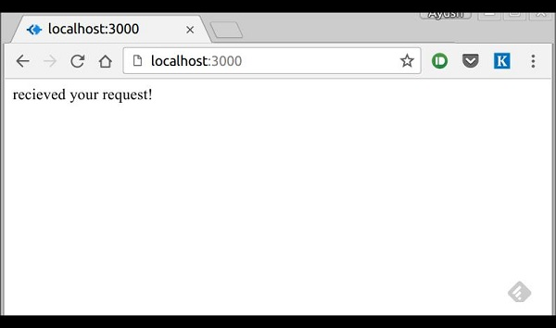

Have a look at your console; it will show you the body of your request as a JavaScript object as in the following screenshot −

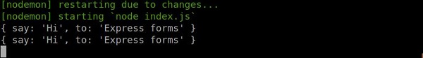

The **req.body** object contains your parsed request body. To use fields from that object, just use them like normal JS objects.

This is the most recommended way to send a request. There are many other ways, but those are irrelevant to cover here, because our Express app will handle all those requests in the same way. To read more about different ways to make a request, have a look at [this](https://developer.mozilla.org/en-US/docs/Web/Guide/HTML/Forms/Sending_forms_through_JavaScript) page.

**Express JS Database**

We keep receiving requests, but end up not storing them anywhere. We need a Database to store the data. For this, we will make use of the NoSQL database called **MongoDB**.

To install and read about Mongo, follow [this link.](https://www.tutorialspoint.com/mongodb/mongodb_environment.htm)

In order to use Mongo with Express, we need a client API for node. There are multiple options for us, but for this tutorial, we will stick to [mongoose](http://mongoosejs.com/). Mongoose is used for **document Modeling** in Node for MongoDB. For document modeling, we create a **Model** (much like a **class** in document oriented programming), and then we produce **documents** using this Model (like we create **documents of a class** in OOP). All our processing will be done on these "documents", then finally, we will write these documents in our database.

## Setting up Mongoose

Now that you have installed Mongo, let us install Mongoose, the same way we have been installing our other node packages −

npm install --save mongoose

Before we start using mongoose, we have to create a database using the Mongo shell. To create a new database, open your terminal and enter "mongo". A Mongo shell will start, enter the following code −

use my\_db

A new database will be created for you. Whenever you open up the mongo shell, it will default to "test" db and you will have to change to your database using the same command as above.

To use Mongoose, we will require it in our **index.js** file and then connect to the **mongodb** service running on **mongodb://localhost**.

var mongoose = require('mongoose');

mongoose.connect('mongodb://localhost/my\_db');

Now our app is connected to our database, let us create a new Model. This model will act as a collection in our database. To create a new Model, use the following code, before defining any route −

var personSchema = mongoose.Schema({

name: String,

age: Number,

nationality: String

});

var Person = mongoose.model("Person", personSchema);

The above code defines the schema for a person and is used to create a Mongoose Mode **Person**.

## Saving Documents

Now, we will create a new html form; this form will help you get the details of a person and save it to our database. To create the form, create a new view file called **person.pug** in views directory with the following content −

html

head

title Person

body

form(action = "/person", method = "POST")

div

label(for = "name") Name:

input(name = "name")

br

div

label(for = "age") Age:

input(name = "age")

br

div

label(for = "nationality") Nationality:

input(name = "nationality")

br

button(type = "submit") Create new person

Also add a **new get route** in **index.js** to render this document −

app.get('/person', function(req, res){

res.render('person');

});

Go to "**localhost:3000/person**" to check if the form is displaying the correct output. Note that this is just the UI, it is not working yet. The following screenshot shows how the form is displayed −

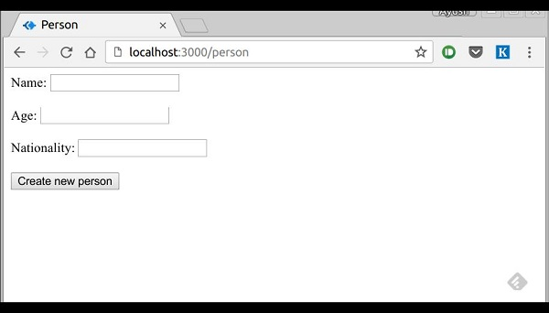

We will now define a post route handler at **'/person'** which will handle this request

app.post('/person', function(req, res){

var personInfo = req.body; //Get the parsed information

if(!personInfo.name || !personInfo.age || !personInfo.nationality){

res.render('show\_message', {

message: "Sorry, you provided worng info", type: "error"});

} else {

var newPerson = new Person({

name: personInfo.name,

age: personInfo.age,

nationality: personInfo.nationality

});

newPerson.save(function(err, Person){

if(err)

res.render('show\_message', {message: "Database error", type: "error"});

else

res.render('show\_message', {

message: "New person added", type: "success", person: personInfo});

});

}

});

In the above code, if we receive any empty field or do not receive any field, we will send an error response. But if we receive a well-formed document, then we create a **newPerson** document from Person model and save it to our DB using the **newPerson.save()** function. This is defined in Mongoose and accepts a callback as argument. This callback has 2 arguments – error and response. These arguments will render the **show\_message** view.

To show the response from this route, we will also need to create a **show\_message** view. Create a new view with the following code −

html

head

title Person

body

if(type == "error")

h3(style = "color:red") #{message}

else

h3 New person,

name: #{person.name},

age: #{person.age} and

nationality: #{person.nationality} added!

We will receive the following response on successfully submitting the **form(show\_message.pug)** −

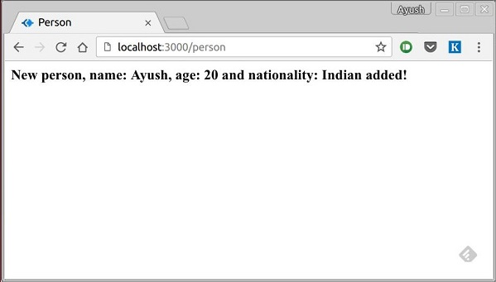

We now have an interface to create **persons**.

## Retrieving Documents

Mongoose provides a lot of functions for retrieving documents, we will focus on 3 of those. All these functions also take a callback as the last parameter, and just like the save function, their arguments are error and response. The three functions are as follows −

### Model.find(conditions, callback)

This function finds all the documents matching the fields in conditions object. Same operators used in Mongo also work in mongoose. For example,

Person.find(function(err, response){

console.log(response);

});

This will fetch all the documents from the person's collection.

Person.find({name: "Ayush", age: 20},

function(err, response){

console.log(response);

});

This will fetch all documents where field name is "Ayush" and age is 20.

We can also provide projection we need, i.e., the fields we need. For example, if we want only the **names** of people whose **nationality** is *"Indian"*, we use −

Person.find({nationality: "Indian"}, "name", function(err, response){

console.log(response);

});

### Model.findOne(conditions, callback)

This function always fetches a single, most relevant document. It has the same exact arguments as **Model.find()**.

### Model.findById(id, callback)

This function takes in the **\_id**(defined by mongo) as the first argument, an optional projection string and a callback to handle the response. For example,

Person.findById("507f1f77bcf86cd799439011", function(err, response){

console.log(response);

});

Let us now create a route to view all people records −

var express = require('express');

var app = express();

var mongoose = require('mongoose');

mongoose.connect('mongodb://localhost/my\_db');

var personSchema = mongoose.Schema({

name: String,

age: Number,

nationality: String

});

var Person = mongoose.model("Person", personSchema);

app.get('/people', function(req, res){

Person.find(function(err, response){

res.json(response);

});

});

app.listen(3000);

## Updating Documents

Mongoose provides 3 functions to update documents. The functions are described below −

### Model.update(condition, updates, callback)

This function takes a conditions and updates an object as input and applies the changes to all the documents matching the conditions in the collection. For example, following code will update the nationality "American" in all Person documents −

Person.update({age: 25}, {nationality: "American"}, function(err, response){

console.log(response);

});

### Model.findOneAndUpdate(condition, updates, callback)

It finds one document based on the query and updates that according to the second argument. It also takes a callback as last argument. Let us perform the following example to understand the function

Person.findOneAndUpdate({name: "Ayush"}, {age: 40}, function(err, response) {

console.log(response);

});

### Model.findByIdAndUpdate(id, updates, callback)

This function updates a single document identified by its id. For example,

Person.findByIdAndUpdate("507f1f77bcf86cd799439011", {name: "James"},

function(err, response){

console.log(response);

});

Let us now create a route to update people. This will be a **PUT** route with the id as a parameter and details in the payload.

var express = require('express');

var app = express();

var mongoose = require('mongoose');

mongoose.connect('mongodb://localhost/my\_db');

var personSchema = mongoose.Schema({

name: String,

age: Number,

nationality: String

});

var Person = mongoose.model("Person", personSchema);

app.put('/people/:id', function(req, res){

Person.findByIdAndUpdate(req.params.id, req.body, function(err, response){

if(err) res.json({message: "Error in updating person with id " + req.params.id});

res.json(response);

});

});

app.listen(3000);

To test this route, enter the following in your terminal (replace the id with an id from your created **people**) −

curl -X PUT --data "name = James&age = 20&nationality = American

"http://localhost:3000/people/507f1f77bcf86cd799439011

This will update the document associated with the id provided in the route with the above details.

## Deleting Documents

We have covered **Create, Read** and **Update**, now we will see how Mongoose can be used to **Delete** documents. We have 3 functions here, exactly like update.

### Model.remove(condition, [callback])

This function takes a condition object as input and removes all documents matching the conditions. For example, if we need to remove all people aged 20, use the following syntax −

Person.remove({age:20});

### Model.findOneAndRemove(condition, [callback])

This functions removes a **single**, most relevant document according to conditions object. Let us execute the following code to understand the same.

Person.findOneAndRemove({name: "Ayush"});

### Model.findByIdAndRemove(id, [callback])

This function removes a single document identified by its id. For example,

Person.findByIdAndRemove("507f1f77bcf86cd799439011");

Let us now create a route to delete people from our database.

var express = require('express');

var app = express();

var mongoose = require('mongoose');

mongoose.connect('mongodb://localhost/my\_db');

var personSchema = mongoose.Schema({

name: String,

age: Number,

nationality: String

});

var Person = mongoose.model("Person", personSchema);

app.delete('/people/:id', function(req, res){

Person.findByIdAndRemove(req.params.id, function(err, response){

if(err) res.json({message: "Error in deleting record id " + req.params.id});

else res.json({message: "Person with id " + req.params.id + " removed."});

});

});

app.listen(3000);

To check the output, use the following curl command −

curl -X DELETE http://localhost:3000/people/507f1f77bcf86cd799439011

This will remove the person with given id producing the following message −

{message: "Person with id 507f1f77bcf86cd799439011 removed."}

This wraps up how we can create simple CRUD applications using MongoDB, Mongoose and Express. To explore Mongoose further, read the [API docs.](http://mongoosejs.com/)

**Express JS Cookies**

Cookies are simple, small files/data that are sent to client with a server request and stored on the client side. Every time the user loads the website back, this cookie is sent with the request. This helps us keep track of the user’s actions.

The following are the numerous uses of the HTTP Cookies −

* Session management
* Personalization(Recommendation systems)
* User tracking

To use cookies with Express, we need the cookie-parser middleware. To install it, use the following code −

npm install --save cookie-parser

Now to use cookies with Express, we will require the **cookie-parser**. cookie-parser is a middleware which *parses cookies attached to the client request object*. To use it, we will require it in our **index.js** file; this can be used the same way as we use other middleware. Here, we will use the following code.

var cookieParser = require('cookie-parser');

app.use(cookieParser());

cookie-parser parses Cookie header and populates **req.cookies** with an object keyed by the cookie names. To set a new cookie, let us define a new route in your Express app like −

var express = require('express');

var app = express();

app.get('/', function(req, res){

res.cookie('name', 'express').send('cookie set'); //Sets name = express

});

app.listen(3000);

To check if your cookie is set or not, just go to your browser, fire up the console, and enter −

console.log(document.cookie);

You will get the output like (you may have more cookies set maybe due to extensions in your browser) −

"name = express"

The browser also sends back cookies every time it queries the server. To view cookies from your server, on the server console in a route, add the following code to that route.

console.log('Cookies: ', req.cookies);

Next time you send a request to this route, you will receive the following output.

Cookies: { name: 'express' }

## Adding Cookies with Expiration Time

You can add cookies that expire. To add a cookie that expires, just pass an object with property 'expire' set to the time when you want it to expire. For example,

//Expires after 360000 ms from the time it is set.

res.cookie(name, 'value', {expire: 360000 + Date.now()});

Another way to set expiration time is using **'maxAge'** property. Using this property, we can provide relative time instead of absolute time. Following is an example of this method.

//This cookie also expires after 360000 ms from the time it is set.

res.cookie(name, 'value', {maxAge: 360000});

## Deleting Existing Cookies

To delete a cookie, use the clearCookie function. For example, if you need to clear a cookie named **foo**, use the following code.

var express = require('express');

var app = express();

app.get('/clear\_cookie\_foo', function(req, res){

res.clearCookie('foo');

res.send('cookie foo cleared');

});

app.listen(3000);

In the next chapter, we will see how to use cookies to manage sessions.

**Express JS Sessions**

HTTP is stateless; in order to associate a request to any other request, you need a way to store user data between HTTP requests. Cookies and URL parameters are both suitable ways to transport data between the client and the server. But they are both readable and on the client side. Sessions solve exactly this problem. You assign the client an ID and it makes all further requests using that ID. Information associated with the client is stored on the server linked to this ID.

We will need the *Express-session*, so install it using the following code.

npm install --save express-session

We will put the **session** and **cookie-parser** middleware in place. In this example, we will use the default store for storing sessions, i.e., MemoryStore. Never use this in production environments. The session middleware handles all things for us, i.e., creating the session, setting the session cookie and creating the session object in **req** object.

Whenever we make a request from the same client again, we will have their session information stored with us (given that the server was not restarted). We can add more properties to the session object. In the following example, we will create a view counter for a client.

var express = require('express');

var cookieParser = require('cookie-parser');

var session = require('express-session');

var app = express();

app.use(cookieParser());

app.use(session({secret: "Shh, its a secret!"}));

app.get('/', function(req, res){

if(req.session.page\_views){

req.session.page\_views++;

res.send("You visited this page " + req.session.page\_views + " times");

} else {

req.session.page\_views = 1;

res.send("Welcome to this page for the first time!");

}

});

app.listen(3000);

What the above code does is, when a user visits the site, it creates a new session for the user and assigns them a cookie. Next time the user comes, the cookie is checked and the **page\_view** session variable is updated accordingly.

Now if you run the app and go to **localhost:3000**, the following output will be displayed.

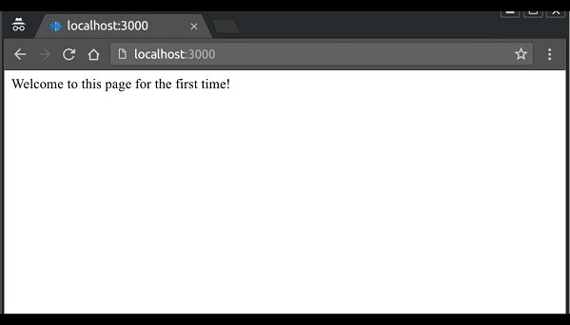

If you revisit the page, the page counter will increase. The page in the following screenshot was refreshed 42 times.

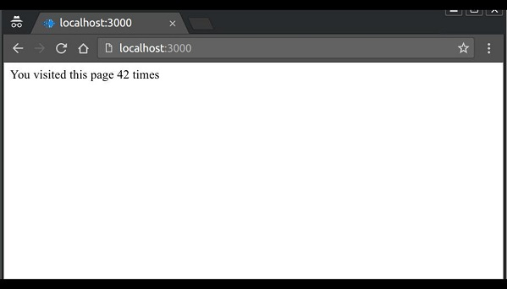

**Express JS Authentications**

Authentication is a process in which the credentials provided are compared to those on file in a database of authorized users' information on a local operating system or within an authentication server. If the credentials match, the process is completed and the user is granted authorization for access.

For us to create an authentication system, we will need to create a sign up page and a user-password store. The following code creates an account for us and stores it in memory. This is just for the purpose of demo; it is recommended that a persistent storage (database or files) is always used to store user information.

var express = require('express');

var app = express();

var bodyParser = require('body-parser');

var multer = require('multer');

var upload = multer();

var session = require('express-session');

var cookieParser = require('cookie-parser');

app.set('view engine', 'pug');

app.set('views','./views');

app.use(bodyParser.json());

app.use(bodyParser.urlencoded({ extended: true }));

app.use(upload.array());

app.use(cookieParser());

app.use(session({secret: "Your secret key"}));

var Users = [];

app.get('/signup', function(req, res){

res.render('signup');

});

app.post('/signup', function(req, res){

if(!req.body.id || !req.body.password){

res.status("400");

res.send("Invalid details!");

} else {

Users.filter(function(user){

if(user.id === req.body.id){

res.render('signup', {

message: "User Already Exists! Login or choose another user id"});

}

});

var newUser = {id: req.body.id, password: req.body.password};

Users.push(newUser);

req.session.user = newUser;

res.redirect('/protected\_page');

}

});

app.listen(3000);

Now for the signup form, create a new view called **signup.jade.**

### SIGNUP.JADE

html

head

title Signup

body

if(message)

h4 #{message}

form(action = "/signup" method = "POST")

input(name = "id" type = "text" required placeholder = "User ID")

input(name = "password" type = "password" required placeholder = "Password")

button(type = "Submit") Sign me up!

Check if this page loads by visiting localhost:3000/signup.

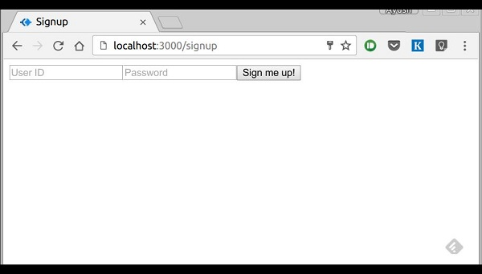

We have set the required attribute for both fields, so HTML5 enabled browsers will not let us submit this form until we provide both id and password. If someone tries to register using a curl request without a User ID or Password, an error will be displayed. Create a new file called **protected\_page.pug** in views with the following content −

html

head

title Protected page

body

div Hey #{id}, How are you doing today?

div Want to log out?

div Logout

This page should only be visible if the user has just signed up or logged in. Let us now define its route and also routes to log in and log out −

var express = require('express');

var app = express();

var bodyParser = require('body-parser');

var multer = require('multer');

var upload = multer();

var session = require('express-session');

var cookieParser = require('cookie-parser');

app.set('view engine', 'pug');

app.set('views','./views');

app.use(bodyParser.json());

app.use(bodyParser.urlencoded({ extended: true }));

app.use(upload.array());

app.use(cookieParser());

app.use(session({secret: "Your secret key"}));

var Users = [];

app.get('/signup', function(req, res){

res.render('signup');

});

app.post('/signup', function(req, res){

if(!req.body.id || !req.body.password){

res.status("400");

res.send("Invalid details!");

} else {

Users.filter(function(user){

if(user.id === req.body.id){

res.render('signup', {

message: "User Already Exists! Login or choose another user id"});

}

});

var newUser = {id: req.body.id, password: req.body.password};

Users.push(newUser);

req.session.user = newUser;

res.redirect('/protected\_page');

}

});

function checkSignIn(req, res){

if(req.session.user){

next(); //If session exists, proceed to page

} else {

var err = new Error("Not logged in!");

console.log(req.session.user);

next(err); //Error, trying to access unauthorized page!

}

}

app.get('/protected\_page', checkSignIn, function(req, res){

res.render('protected\_page', {id: req.session.user.id})

});

app.get('/login', function(req, res){

res.render('login');

});

app.post('/login', function(req, res){

console.log(Users);

if(!req.body.id || !req.body.password){

res.render('login', {message: "Please enter both id and password"});

} else {

Users.filter(function(user){

if(user.id === req.body.id && user.password === req.body.password){

req.session.user = user;

res.redirect('/protected\_page');

}

});

res.render('login', {message: "Invalid credentials!"});

}

});

app.get('/logout', function(req, res){

req.session.destroy(function(){

console.log("user logged out.")

});

res.redirect('/login');

});

app.use('/protected\_page', function(err, req, res, next){

console.log(err);

//User should be authenticated! Redirect him to log in.

res.redirect('/login');

});

app.listen(3000);

We have created a middleware function *checkSignIn* to check if the user is signed in. The **protected\_page** uses this function. To log the user out, we destroy the session.

Let us now create the login page. Name the view as **login.pug** and enter the contents −

html

head

title Signup

body

if(message)

h4 #{message}

form(action = "/login" method = "POST")

input(name = "id" type = "text" required placeholder = "User ID")

input(name = "password" type = "password" required placeholder = "Password")

button(type = "Submit") Log in

Our simple authentication application is now complete; let us now test the application. Run the app using *nodemon index.js*, and proceed to localhost:3000/signup.

Enter a Username and a password and click sign up. You will be redirected to the **protected\_page** if details are valid/unique −

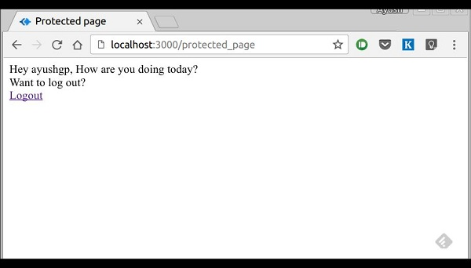

Now log out of the app. This will redirect us to the login page −

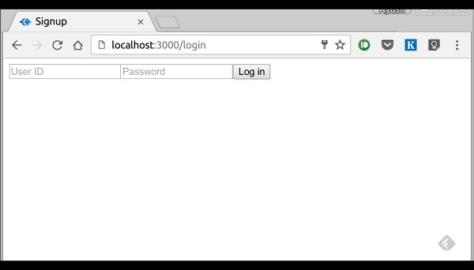

This route is protected such that if an unauthenticated person tries to visit it, he will be edirected to our login page. This was all about basic user authentication. It is always recommended that we use a persistent session system and use hashes for password transport. There are much better ways to authenticate users now, leveraging JSON tokens.

**Express JS Restful APIS**

An API is always needed to create mobile applications, single page applications, use AJAX calls and provide data to clients. An popular architectural style of how to structure and name these APIs and the endpoints is called **REST(Representational Transfer State)**. **HTTP 1.1** was designed keeping REST principles in mind. REST was introduced by **Roy Fielding** in 2000 in his Paper Fielding Dissertations.

RESTful URIs and methods provide us with almost all information we need to process a request. The table given below summarizes how the various verbs should be used and how URIs should be named. We will be creating a movies API towards the end; let us now discuss how it will be structured.

|  |  |  |  |
| --- | --- | --- | --- |
| **Method** | **URI** | **Details** | **Function** |
| GET | /movies | Safe, cachable | Gets the list of all movies and their details |
| GET | /movies/1234 | Safe, cachable | Gets the details of Movie id 1234 |
| POST | /movies | N/A | Creates a new movie with the details provided. Response contains the URI for this newly created resource. |
| PUT | /movies/1234 | Idempotent | Modifies movie id 1234(creates one if it doesn't already exist). Response contains the URI for this newly created resource. |
| DELETE | /movies/1234 | Idempotent | Movie id 1234 should be deleted, if it exists. Response should contain the status of the request. |
| DELETE or PUT | /movies | Invalid | Should be invalid. **DELETE** and **PUT**should specify which resource they are working on. |

Let us now create this API in Express. We will be using JSON as our transport data format as it is easy to work with in JavaScript and has other benefits. Replace your **index.js** file with the **movies.js** file as in the following program.

## index.js

var express = require('express');

var bodyParser = require('body-parser');

var multer = require('multer');

var upload = multer();

var app = express();

app.use(cookieParser());

app.use(bodyParser.json());

app.use(bodyParser.urlencoded({ extended: true }));

app.use(upload.array());

//Require the Router we defined in movies.js

var movies = require('./movies.js');

//Use the Router on the sub route /movies

app.use('/movies', movies);

app.listen(3000);

Now that we have our application set up, let us concentrate on creating the API.

Start by setting up the movies.js file. We are not using a database to store the movies but are storing them in memory; so every time the server restarts, the movies added by us will vanish. This can easily be mimicked using a database or a file (using node fs module).

Once you import Express then, create a Router and export it using *module.exports* −

var express = require('express');

var router = express.Router();

var movies = [

{id: 101, name: "Fight Club", year: 1999, rating: 8.1},

{id: 102, name: "Inception", year: 2010, rating: 8.7},

{id: 103, name: "The Dark Knight", year: 2008, rating: 9},

{id: 104, name: "12 Angry Men", year: 1957, rating: 8.9}

];

//Routes will go here

module.exports = router;

## GET routes

Let us define the GET route for getting all the movies −

router.get('/', function(req, res){

res.json(movies);

});

To test out if this is working fine, run your app, then open your terminal and enter −

curl -i -H "Accept: application/json" -H "Content-Type: application/json" -X GET

localhost:3000/movies

The following response will be displayed −

[{"id":101,"name":"Fight Club","year":1999,"rating":8.1},

{"id":102,"name":"Inception","year":2010,"rating":8.7},

{"id":103,"name":"The Dark Knight","year":2008,"rating":9},

{"id":104,"name":"12 Angry Men","year":1957,"rating":8.9}]

We have a route to get all the movies. Let us now create a route to get a specific movie by its id.

router.get('/:id([0-9]{3,})', function(req, res){

var currMovie = movies.filter(function(movie){

if(movie.id == req.params.id){

return true;

}

});

if(currMovie.length == 1){

res.json(currMovie[0])

} else {

res.status(404);//Set status to 404 as movie was not found

res.json({message: "Not Found"});

}

});

This will get us the movies according to the id that we provided. To check the output, use the following command in your terminal −

curl -i -H "Accept: application/json" -H "Content-Type: application/json" -X GET

localhost:3000/movies/101

You'll get the following response −

{"id":101,"name":"Fight Club","year":1999,"rating":8.1}

If you visit an invalid route, it will produce a **cannot GET error** while if you visit a valid route with an id that doesn’t exist, it will produce a 404 error.

We are done with the GET routes, let us now move on to the **POST** route.

## POST route

Use the following route to handle the **POSTed** data −

router.post('/', function(req, res){

//Check if all fields are provided and are valid:

if(!req.body.name ||

!req.body.year.toString().match(/^[0-9]{4}$/g) ||

!req.body.rating.toString().match(/^[0-9]\.[0-9]$/g)){

res.status(400);

res.json({message: "Bad Request"});

} else {

var newId = movies[movies.length-1].id+1;

movies.push({

id: newId,

name: req.body.name,

year: req.body.year,

rating: req.body.rating

});

res.json({message: "New movie created.", location: "/movies/" + newId});

}

});

This will create a new movie and store it in the movies variable. To check this route, enter the following code in your terminal −

curl -X POST --data "name = Toy%20story&year = 1995&rating = 8.5" http://localhost:3000/movies

The following response will be displayed −

{"message":"New movie created.","location":"/movies/105"}

To test if this was added to the movies object, Run the get request for **/movies/105** again. The following response will be displayed −

{"id":105,"name":"Toy story","year":"1995","rating":"8.5"}

Let us move on to create the PUT and DELETE routes.

## PUT route

The PUT route is almost the same as the POST route. We will be specifying the id for the object that'll be updated/created. Create the route in the following way.

router.put('/:id', function(req, res){

//Check if all fields are provided and are valid:

if(!req.body.name ||

!req.body.year.toString().match(/^[0-9]{4}$/g) ||

!req.body.rating.toString().match(/^[0-9]\.[0-9]$/g) ||

!req.params.id.toString().match(/^[0-9]{3,}$/g)){

res.status(400);

res.json({message: "Bad Request"});

} else {

//Gets us the index of movie with given id.

var updateIndex = movies.map(function(movie){

return movie.id;

}).indexOf(parseInt(req.params.id));

if(updateIndex === -1){

//Movie not found, create new

movies.push({

id: req.params.id,

name: req.body.name,

year: req.body.year,

rating: req.body.rating

});

res.json({message: "New movie created.", location: "/movies/" + req.params.id});

} else {

//Update existing movie

movies[updateIndex] = {

id: req.params.id,

name: req.body.name,

year: req.body.year,

rating: req.body.rating

};

res.json({message: "Movie id " + req.params.id + " updated.",

location: "/movies/" + req.params.id});

}

}

});

This route will perform the function specified in the above table. It will update the object with new details if it exists. If it doesn't exist, it will create a new object. To check the route, use the following curl command. This will update an existing movie. To create a new Movie, just change the id to a non-existing id.

curl -X PUT --data "name = Toy%20story&year = 1995&rating = 8.5"

http://localhost:3000/movies/101

**Response**

{"message":"Movie id 101 updated.","location":"/movies/101"}

## DELETE route

Use the following code to create a delete route. −

router.delete('/:id', function(req, res){

var removeIndex = movies.map(function(movie){

return movie.id;

}).indexOf(req.params.id); //Gets us the index of movie with given id.

if(removeIndex === -1){

res.json({message: "Not found"});

} else {

movies.splice(removeIndex, 1);

res.send({message: "Movie id " + req.params.id + " removed."});

}

});

Check the route in the same way as we checked the other routes. On successful deletion(for example id 105), you will get the following output −

{message: "Movie id 105 removed."}

Finally, our **movies.js** file will look like the following.

var express = require('express');

var router = express.Router();

var movies = [

{id: 101, name: "Fight Club", year: 1999, rating: 8.1},

{id: 102, name: "Inception", year: 2010, rating: 8.7},

{id: 103, name: "The Dark Knight", year: 2008, rating: 9},

{id: 104, name: "12 Angry Men", year: 1957, rating: 8.9}

];

router.get('/:id([0-9]{3,})', function(req, res){

var currMovie = movies.filter(function(movie){

if(movie.id == req.params.id){

return true;

}

});

if(currMovie.length == 1){

res.json(currMovie[0])

} else {

res.status(404); //Set status to 404 as movie was not found

res.json({message: "Not Found"});

}

});

router.post('/', function(req, res){

//Check if all fields are provided and are valid:

if(!req.body.name ||

!req.body.year.toString().match(/^[0-9]{4}$/g) ||

!req.body.rating.toString().match(/^[0-9]\.[0-9]$/g)){

res.status(400);

res.json({message: "Bad Request"});

} else {

var newId = movies[movies.length-1].id+1;

movies.push({

id: newId,

name: req.body.name,

year: req.body.year,

rating: req.body.rating

});

res.json({message: "New movie created.", location: "/movies/" + newId});

}

});

router.put('/:id', function(req, res) {

//Check if all fields are provided and are valid:

if(!req.body.name ||

!req.body.year.toString().match(/^[0-9]{4}$/g) ||

!req.body.rating.toString().match(/^[0-9]\.[0-9]$/g) ||

!req.params.id.toString().match(/^[0-9]{3,}$/g)){

res.status(400);

res.json({message: "Bad Request"});

} else {

//Gets us the index of movie with given id.

var updateIndex = movies.map(function(movie){

return movie.id;

}).indexOf(parseInt(req.params.id));

if(updateIndex === -1){

//Movie not found, create new

movies.push({

id: req.params.id,

name: req.body.name,

year: req.body.year,

rating: req.body.rating

});

res.json({

message: "New movie created.", location: "/movies/" + req.params.id});

} else {

//Update existing movie

movies[updateIndex] = {

id: req.params.id,

name: req.body.name,

year: req.body.year,

rating: req.body.rating

};

res.json({message: "Movie id " + req.params.id + " updated.",

location: "/movies/" + req.params.id});

}

}

});

router.delete('/:id', function(req, res){

var removeIndex = movies.map(function(movie){

return movie.id;

}).indexOf(req.params.id); //Gets us the index of movie with given id.

if(removeIndex === -1){

res.json({message: "Not found"});

} else {

movies.splice(removeIndex, 1);

res.send({message: "Movie id " + req.params.id + " removed."});

}

});

module.exports = router;

This completes our REST API. Now you can create much more complex applications using this simple architectural style and Express.

**Express JS Scaffolding**

Scaffolding allows us to easily create a **skeleton for a web application**. We manually create our public directory, add middleware, create separate route files, etc. A scaffolding tool sets up all these things for us so that we can directly get started with building our application.

The scaffolder we will use is called **Yeoman**. It is a scaffolding tool built for **Node.js** but also has generators for several other frameworks (like flask, rails, django, etc.). To install Yeoman, enter the following command in your terminal −

npm install -g yeoman

Yeoman uses generators to scaffold out applications. To check out the generators available on **npm** to use with Yeoman, you can click on this [link](http://yeoman.io/generators/). In this tutorial, we will use the *'generator-Express-simple'*. To install this generator, enter the following command in your terminal −

npm install -g generator-express-simple

To use this generator, enter the following command −

yo express-simple test-app

You will be asked a few simple questions like what things you want to use with your app. Select the following answers, or if you already know about these technologies then go about choosing how you want them to be.

express-simple comes with bootstrap and jquery

[?] Select the express version you want: 4.x

[?] Do you want an mvc express app: Yes

[?] Select the css preprocessor you would like to use: sass

[?] Select view engine you would like to use: jade

[?] Select the build tool you want to use for this project: gulp

[?] Select the build tool you want to use for this project: gulp

[?] Select the language you want to use for the build tool: javascript

create public/sass/styles.scss

create public/js/main.js

create views/layout.jade

create views/index.jade

create views/404.jade

create app.js

create config.js

create routes/index.js

create package.json

create bower.json

identical .bowerrc

identical .editorconfig

identical .gitignore

identical .jshintrc

create gulpfile.js

I'm all done. Running bower install & npm install for you to install the

required dependencies. If this fails, try running the command yourself.

It will then create a new application for you, install all the dependencies, add few pages to your application(home page, 404 not found page, etc.) and give you a directory structure to work on.

This generator creates a very simple structure for us. Explore the many generators available for Express and choose the one that fits you right. Steps to working with all generators is the same. You will need to install a generator, run it using Yeoman; it will ask you some questions and then create a skeleton for your application based on your answers.

Express JS Error handling

Error handling in Express is done using middleware. But this middleware has special properties. The error handling middleware are defined in the same way as other middleware functions, except that error-handling functions **MUST have four arguments** instead of three – **err, req, res, next**. For example, to send a response on any error, we can use −

app.use(function(err, req, res, next) {

console.error(err.stack);

res.status(500).send('Something broke!');

});

Till now we were handling errors in the routes itself. The error handling middleware allows us to separate our error logic and send responses accordingly. The next() method we discussed in middleware takes us to next **middleware/route handler**.

For error handling, we have the **next(err)** function. A call to this function skips all middleware and matches us to the next error handler for that route. Let us understand this through an example.

var express = require('express');

var app = express();

app.get('/', function(req, res){

//Create an error and pass it to the next function

var err = new Error("Something went wrong");

next(err);

});

/\*

\* other route handlers and middleware here

\* ....

\*/

//An error handling middleware

app.use(function(err, req, res, next) {

res.status(500);

res.send("Oops, something went wrong.")

});

app.listen(3000);

This error handling middleware can be strategically placed after routes or contain conditions to detect error types and respond to the clients accordingly. The above program will display the following output.

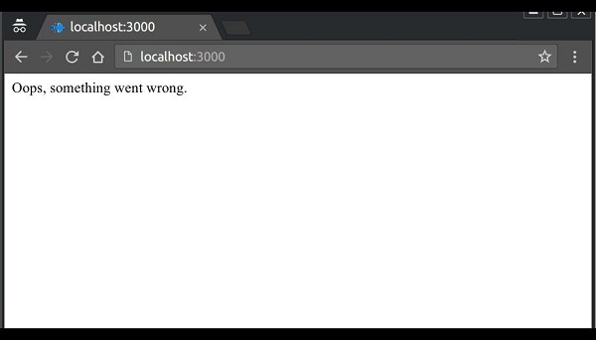

**Express JS Debugging**

Express uses the [Debug](https://www.npmjs.com/package/debug) module to internally log information about route matching, middleware functions, application mode, etc.

To see all internal logs used in Express, set the DEBUG environment variable to **Express:\*** when starting the app −

DEBUG = express:\* node index.js

The following output will be displayed.

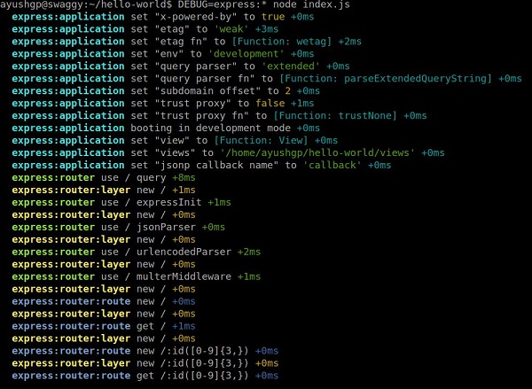

These logs are very helpful when a component of your app is not functioning right. This verbose output might be a little overwhelming. You can also restrict the DEBUG variable to specific area to be logged. For example, if you wish to restrict the logger to application and router, you can use the following code.

DEBUG = express:application,express:router node index.js

Debug is turned off by default and is automatically turned on in production environment. Debug can also be extended to meet your needs, you can read more about it at [its npm page.](https://www.npmjs.com/package/debug)

-----------THE END Wishvanath Anand